Welsh Translations for Care Standard and Primary Health Care lists
Venue screen
English screen
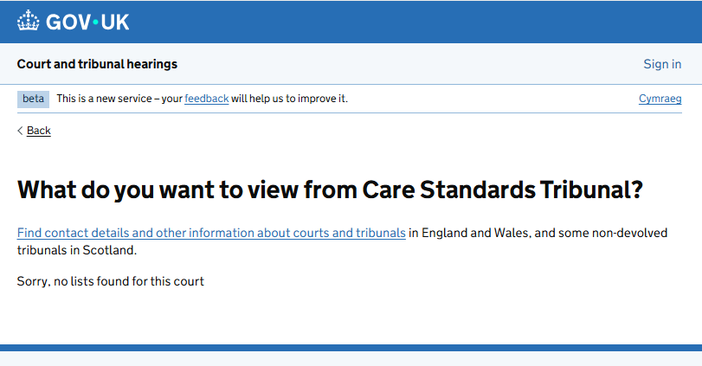

Welsh screen
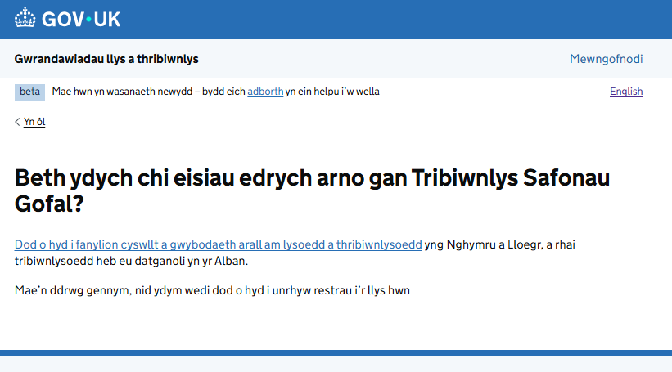

Care Standards Tribunal Weekly Hearing list mock up
English screen
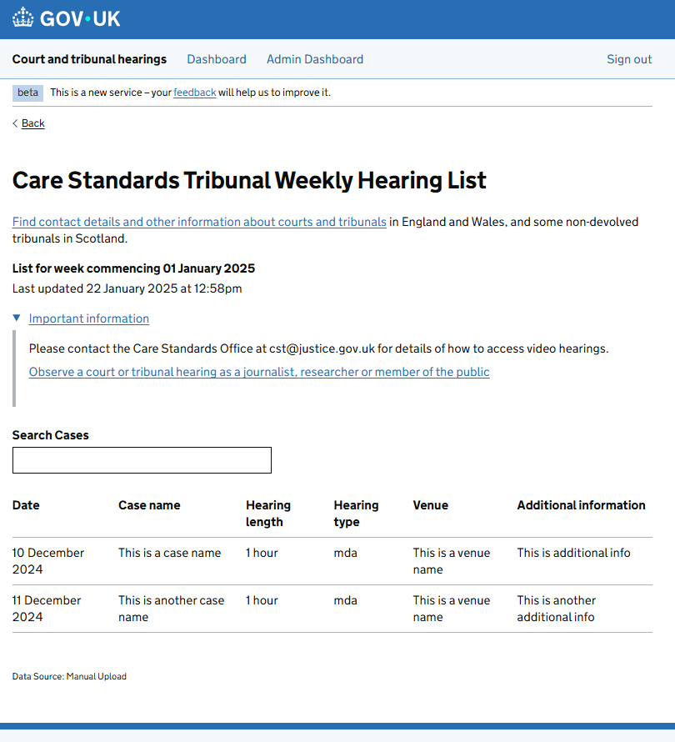

Welsh screen
